Enterprise structure:

**Company hierarchy**

**Purchase Organisation:**

Purchase org is responsible for purchasing or different plants. Here MXN relation exists

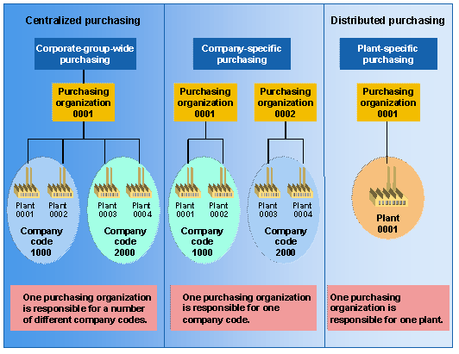

**Purchase Group**

Separation of groups depends on type of purchasing , e.g: asset purchasing, material purchasing.

**Mapping of Purchase organisation with Plants**

Which purchase organisation is responsible for purchasing of which plant.

**User mapping with purchase organisation and purchase group**

Which user belongs to which purchase organisation and purchase group

**\* Currently Woking on Purchase order layout**